Systems integration project testplan.
Cameron hillier.
Test no. | Test name | Expected result | Actual result | Success/failure | proof | comments
1 | Return room | Room 1 | Room 1 returned | success | 1
2 | Return single available room | Room 2 | Room 2 returned | success | 2
3 | Return all available rooms | Room 2 and 3 | Rooms 2 and 3 returned | success | 3
4 | List of hotels | 1,2,3,4 and 5 | Returned 1 2 3 4 and 5 | success | 4
5 | Hotels by rating 5 star | 1 and 2 | Returned rooms 1 and 2 | success | 5
6 | Hotels by rating 4 star | 3 and 4 | Returned 3 and 4 | success | 6
7 | All rooms all hotels | Rooms 1 2 and 3 on all hotels | Rooms 1 2 and 3 on all hotels | success | 7
8 | Billable items | Hotel 5 | Hotel 5 | success | 8

Screenshots
1
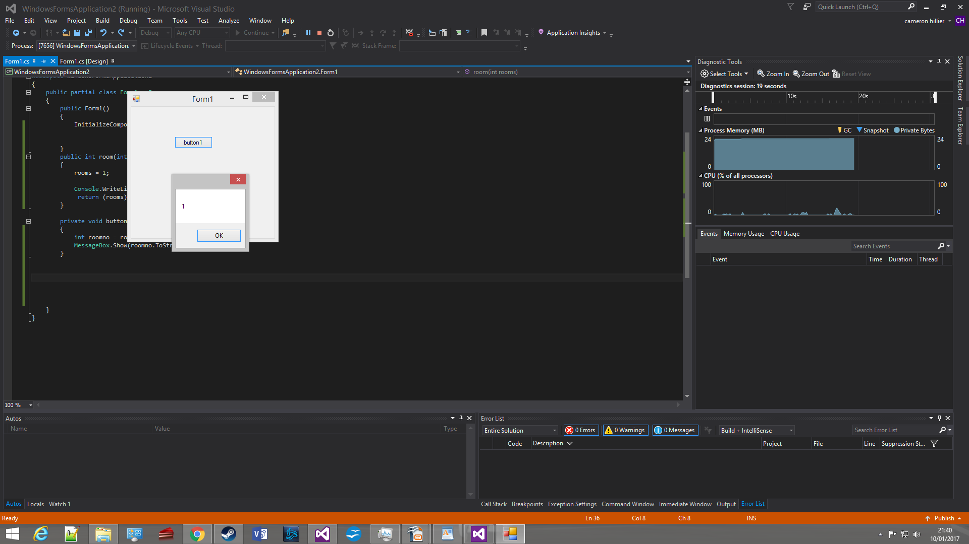
2
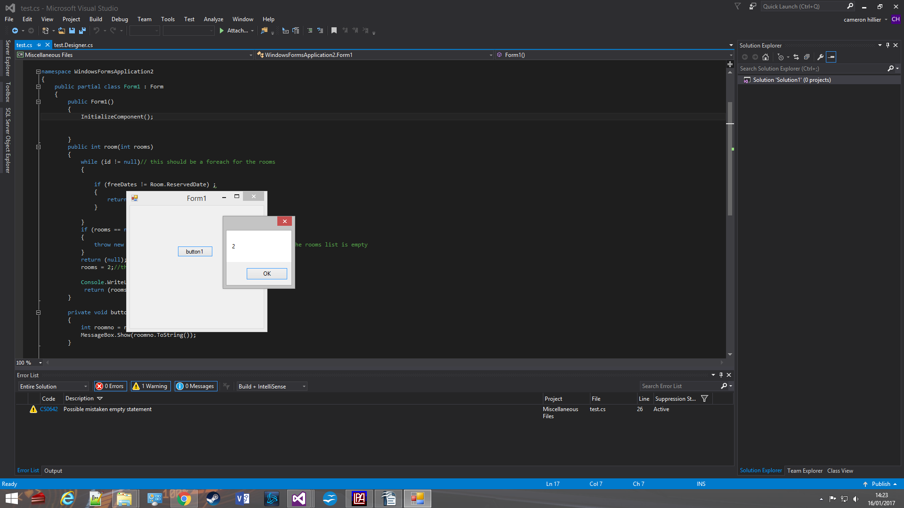
3
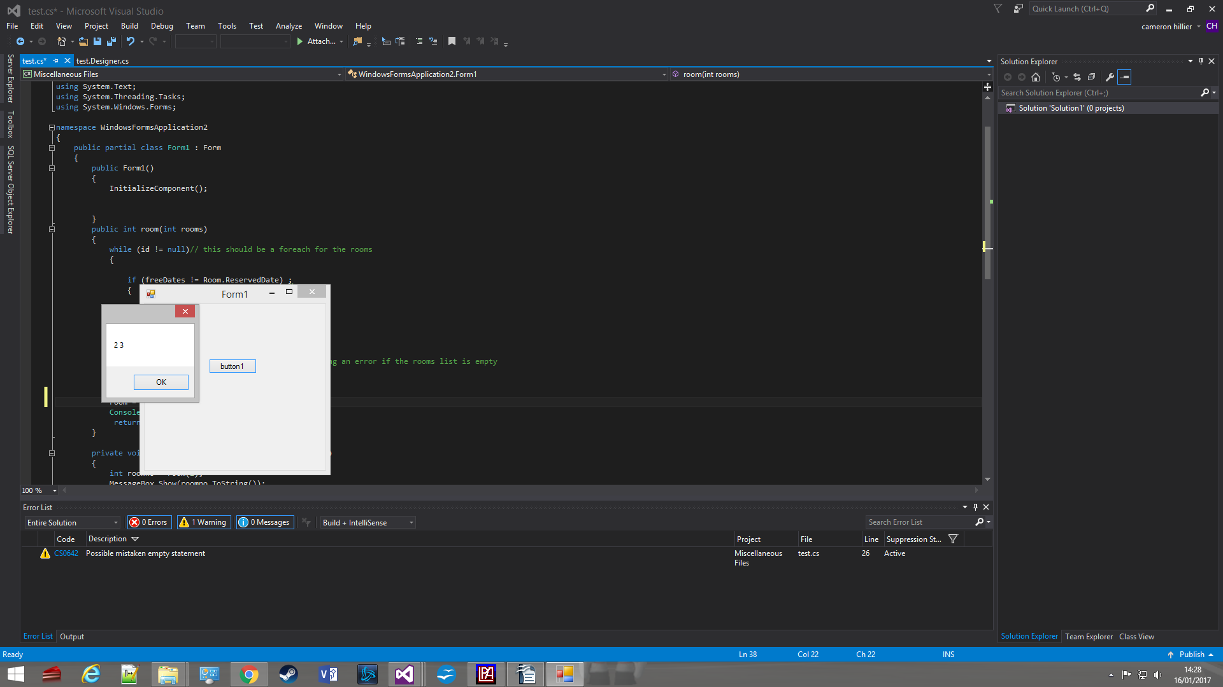
4
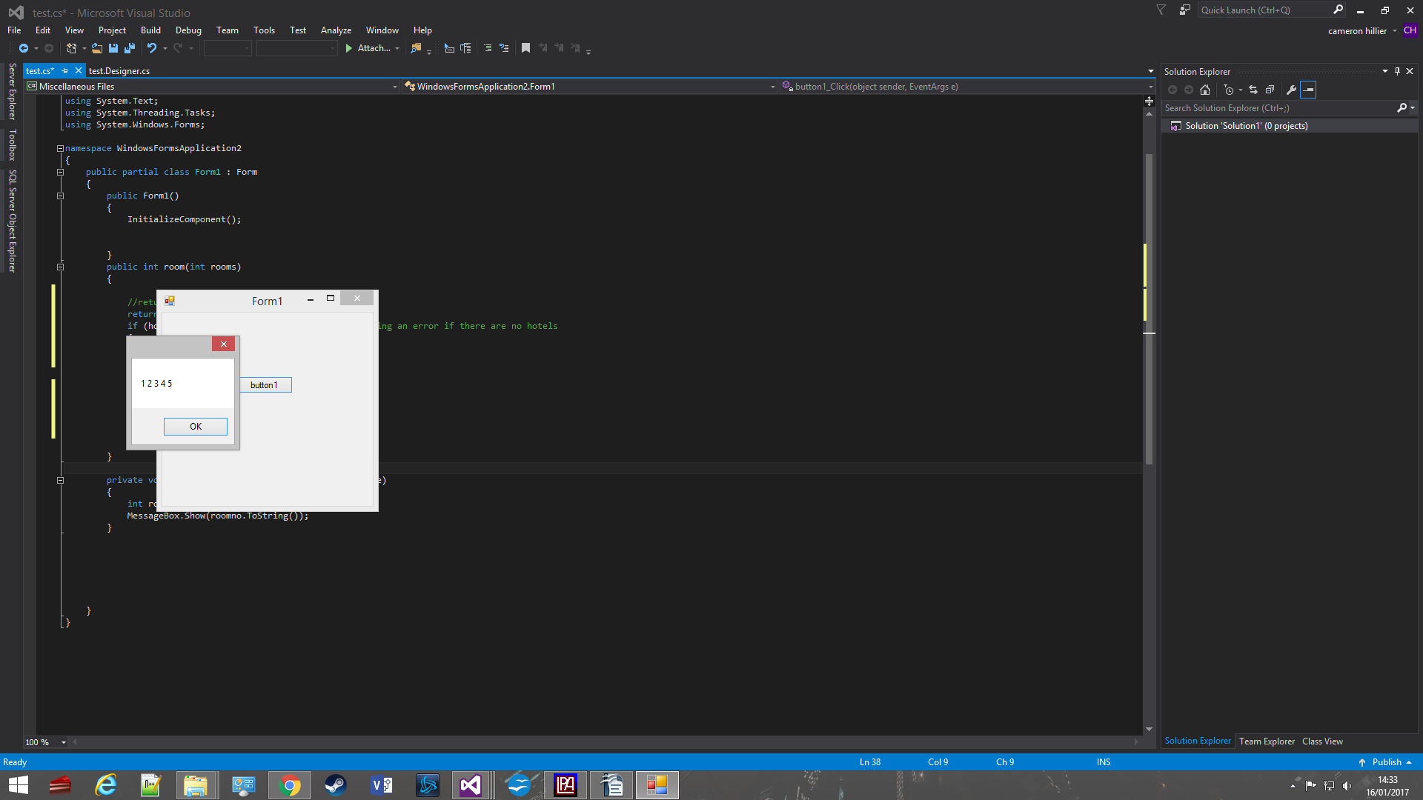
5
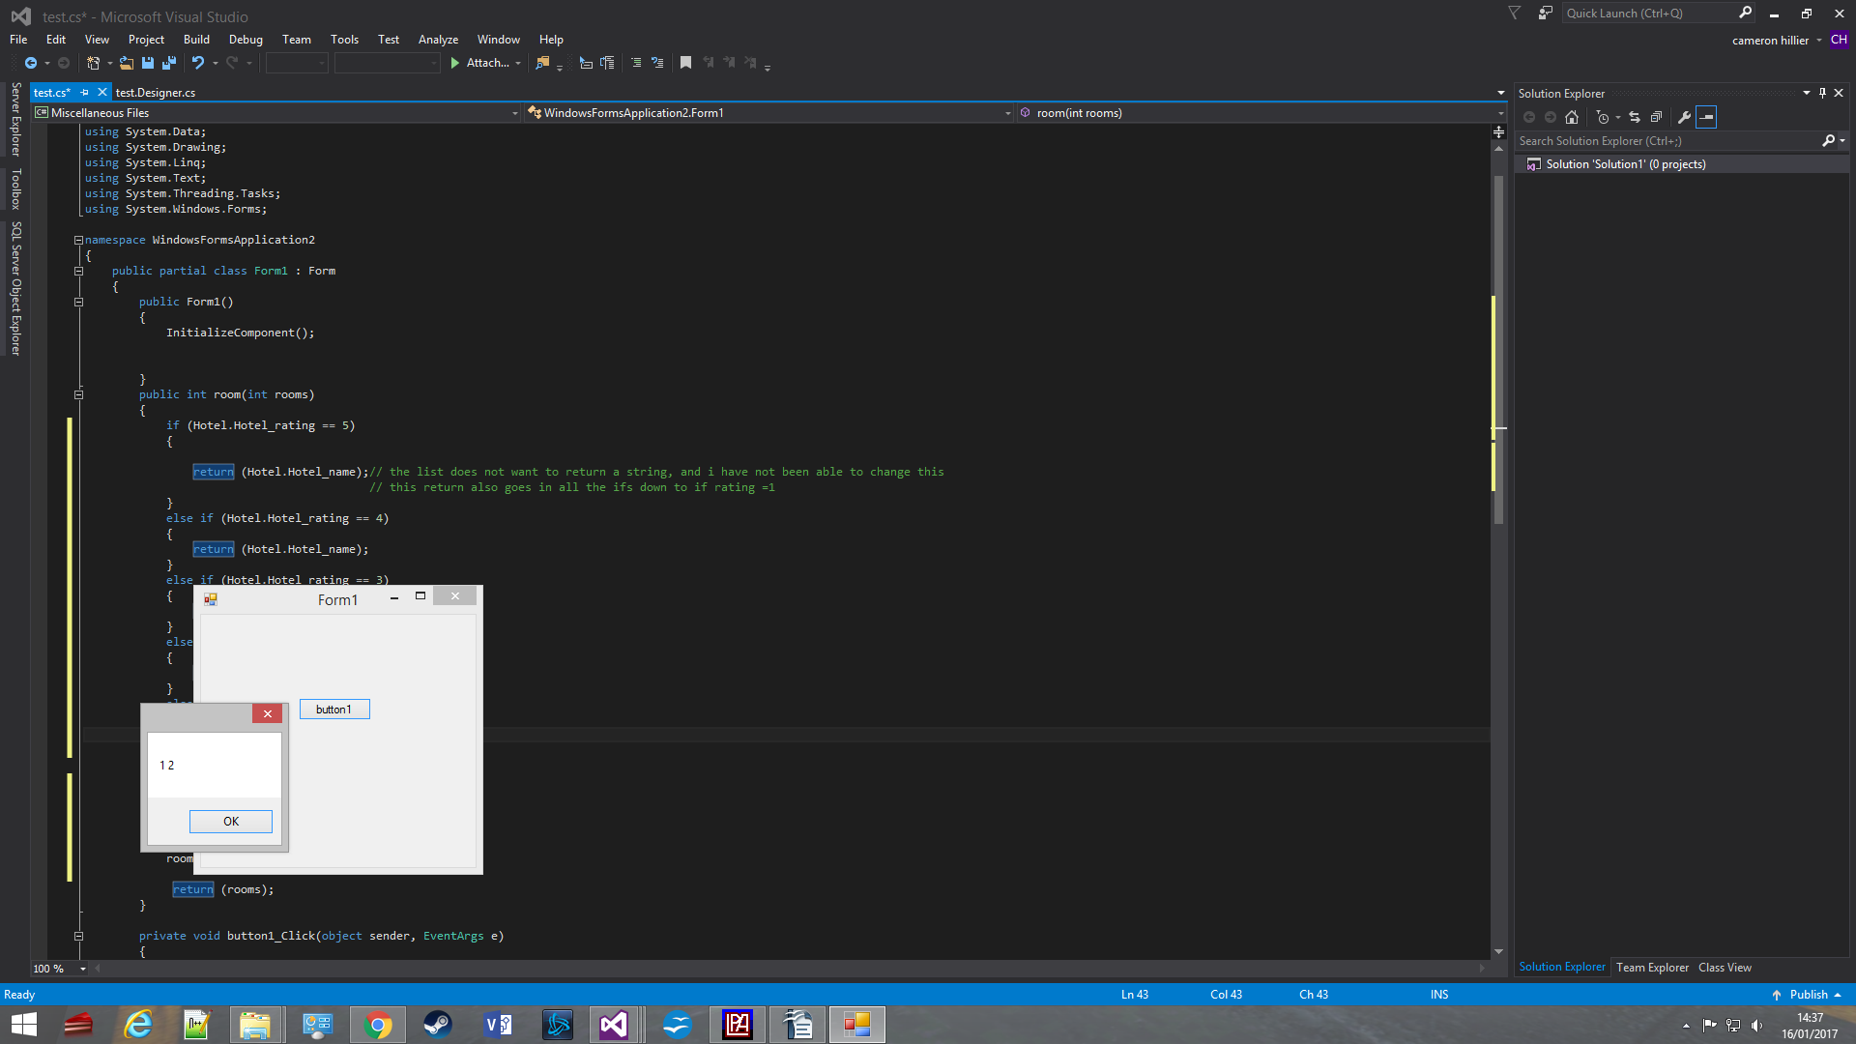
6
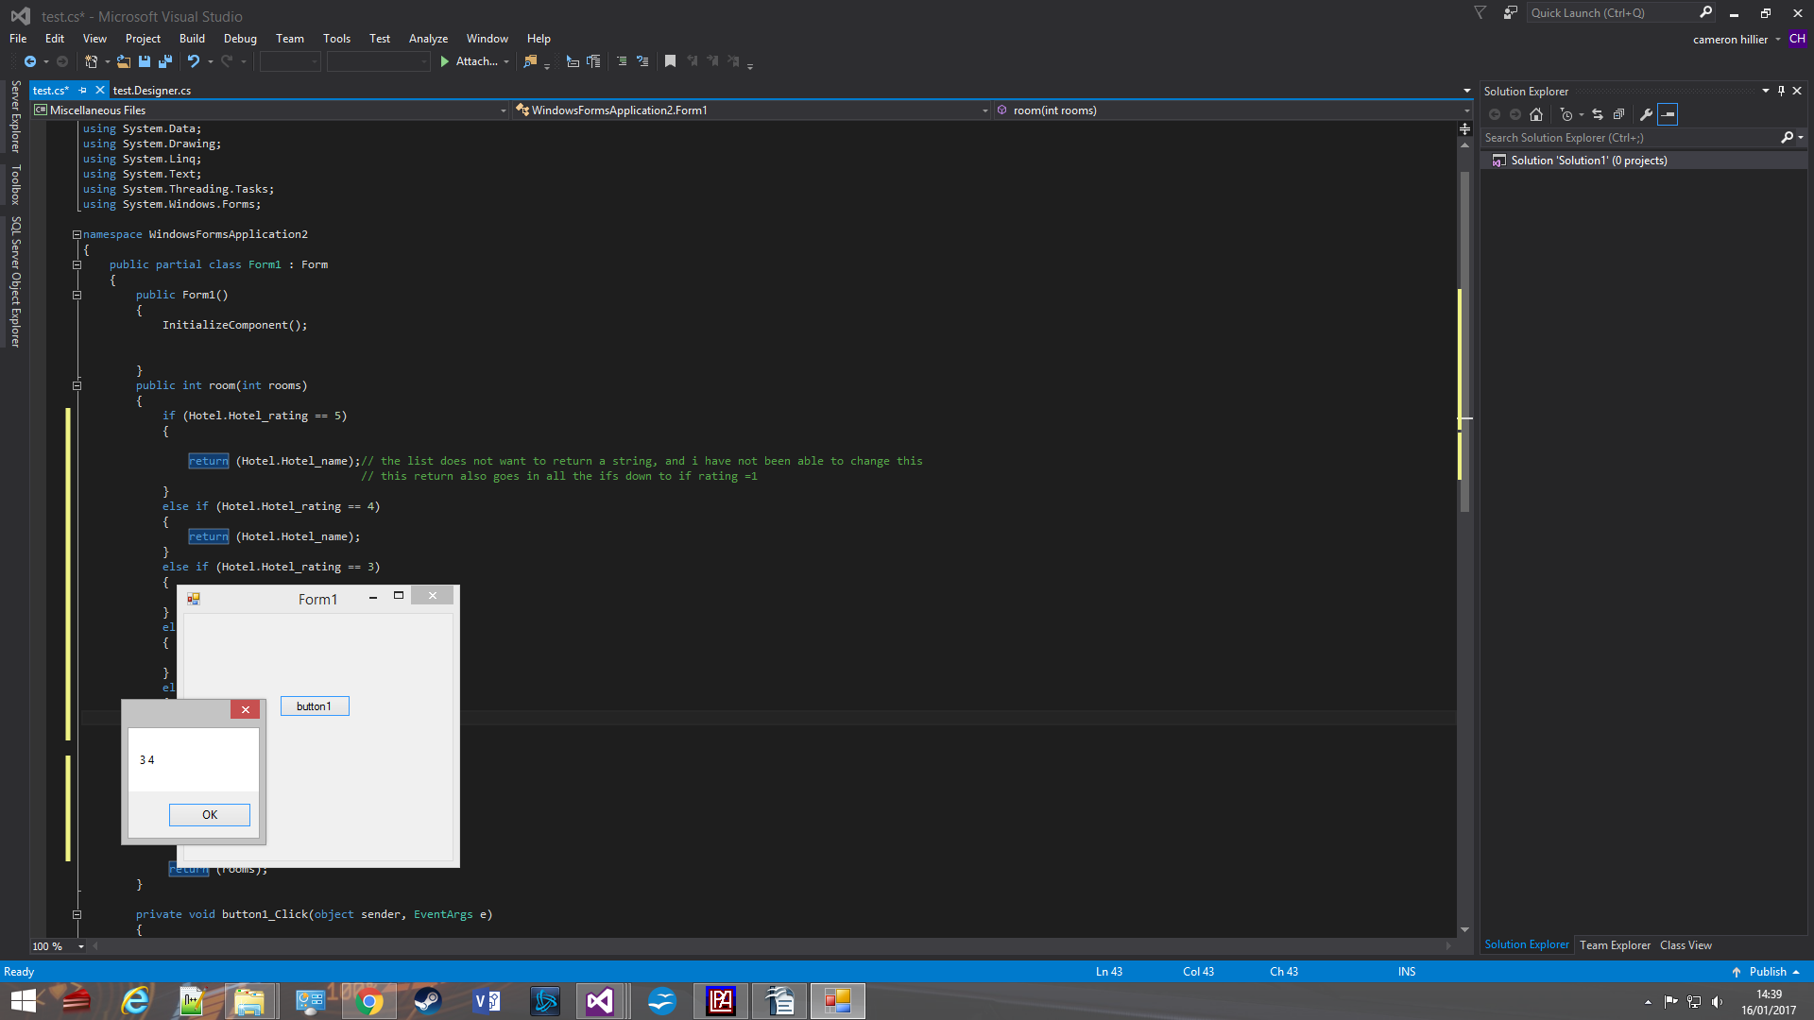
7
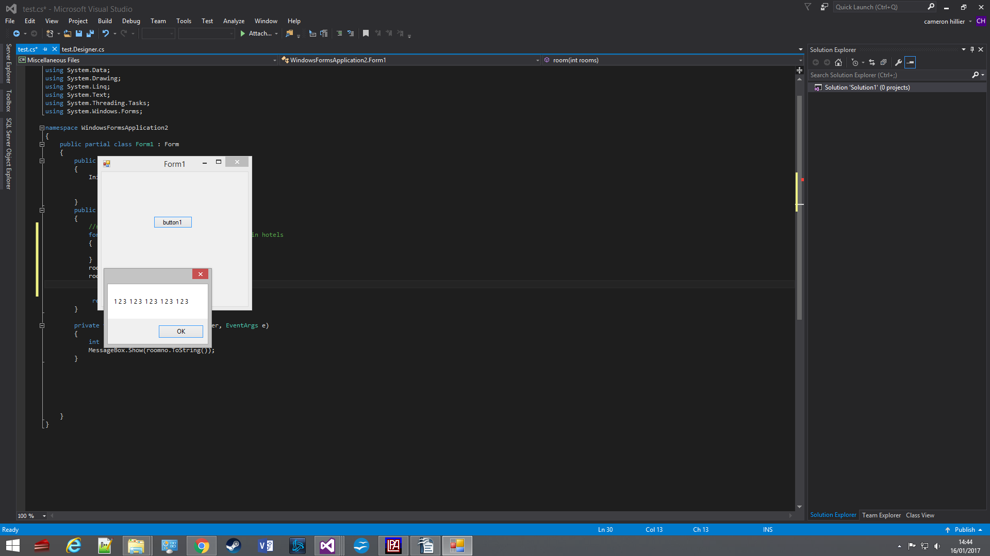
8
